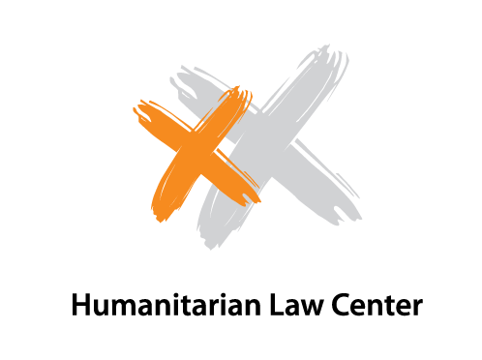

Debate on War Crimes Trials in Serbia in 2012
AGENDA
Media Center, Terazije 3/II
January 17, 2013
12.00 h – 14.30 h

11:45 - 12:00 Registration of the participants
12:00 h - 12:15 h Introductory words:
- Romana Schweiger, Head of the Rule of Law and Human Rights Department, OSCE Mission to Serbia

12:15 h - 12:40 h Presentation of the Report on War Crimes Trials in Serbia in 2012:
- Sandra Orlović, Executive Director, Humanitarian Law Center (HLC
- Milomir Matović, HLC Lawyer and legal representative of the victims in the Tenja II Case
12:40 h - 13:00 h Prosecuting War Crimes Perpetrators, from the perspective of the Office of the Prosecutor for War Crimes, Republic of Serbia :
- Bruno Vekarić, Deputy Prosecutor at the Office for War Crimes, Republic of Serbia
13:00 -13:15 Media reporting on War Crimes Trials:
- Dinko Gruhonjić, journalist and President of Independent Journalists Association of Vojvodina
13:15 h - 14:15 h Discussion
(Moderator: Sandra Orlović)

